Friday Quiz 17th April 2026
- What music festival has just taken place in the Colorado desert?
- Where did a Roman Emperor triumph in the north-west last weekend?
- Which island in the Atlantic is known for the sweet, fortified wine produced there?
- For what specific activity would you be awarded this badge? 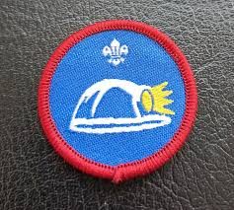
- Which French 19th century adventure novel tells of a young sailor who becomes an aristocrat after finding a cache of hidden treasure?
- Excluding Antarctica, which continent has no island countries?
- Which major US political institution has 100 members?
- Which religious figure was sitting under a tree when they gained enlightenment?
- Name the TV show. 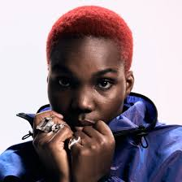 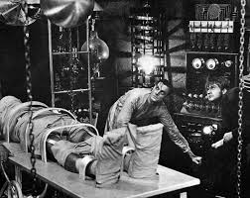

- Name the character 

- What ‘A’ is the name of the metal (or plastic) thingummy on the end of a shoelace?
- Name the game 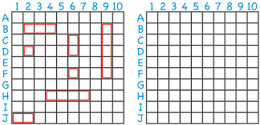
- Who was the first explorer to sail from Europe to India by traveling around Africa?
- What term is used for the Siberian prison system during the reign of Stalin in the Soviet Union?
- In which flm does a Fedex employee end up stranded on a desert island?
- Change the first letter of a footwear provider to find an aeroplane. Give both words.
- Name the film 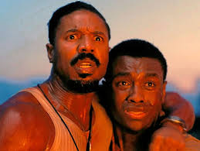
- A passcode is made of four characters. The first character is either A, B or C. The second and third characters are different digits. The fourth character is the units digit obtained when adding the second and third characters together. How many different possible passcodes are there?

- What links the pictures?
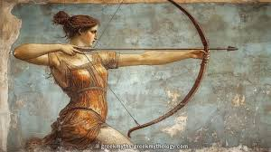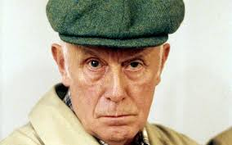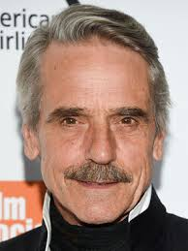
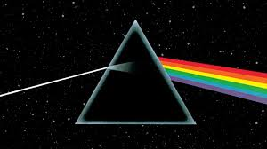

- Unscramble the two words: A A B B F I I I L T U

